Case Study: Vehicle Number Registration

Title : Vehicle Number Registration Validation using JavaScript to verify the correctness of vehicle registration numbers through pattern matching and exception handling.

Software Tools Required
- Visual Studio Code (or any code editor)
- Web Browser
- HTML, CSS and JavaScript

Theory
This case study demonstrates the validation of a vehicle registration number using JavaScript. The entered registration number is processed inside a try-catch block to ensure robust error handling. The program first checks whether the input field is empty and then verifies that the registration number contains exactly ten characters. It uses regular expressions to validate each section sequentially: the first two uppercase letters represent the state code, the next two digits represent the district code, the following two uppercase letters represent the vehicle series, and the last four digits represent the unique vehicle number. Whenever a validation rule fails, a descriptive exception is thrown and displayed to the user in red. If every condition is satisfied, a success message is displayed in green, confirming that the registration number follows the required format.

Code Screenshot
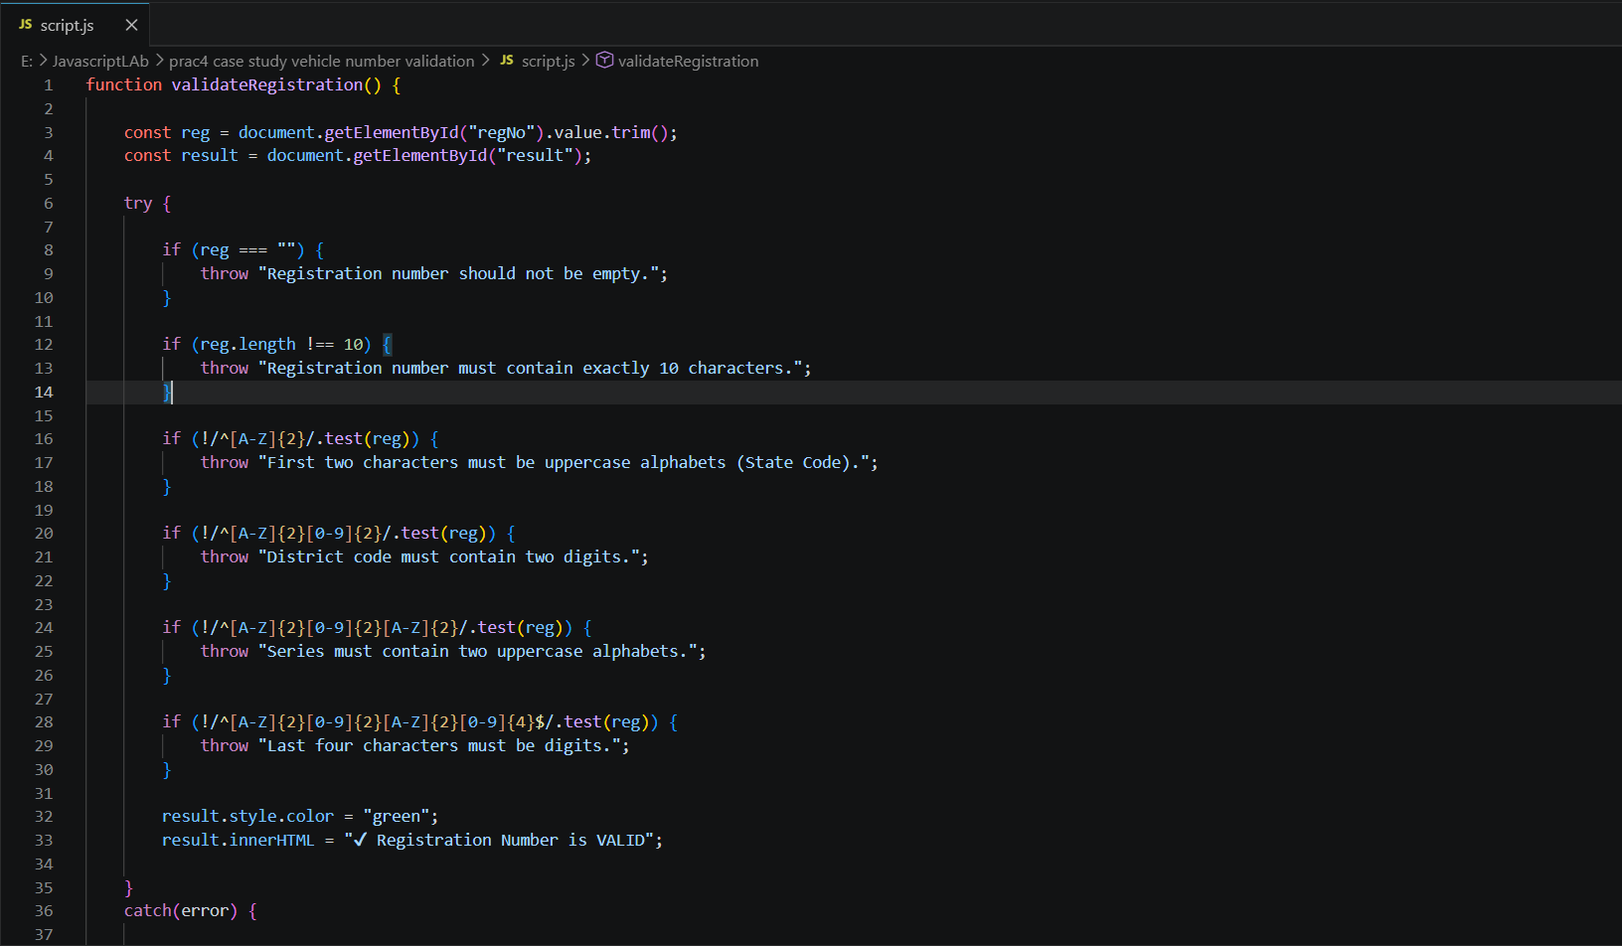
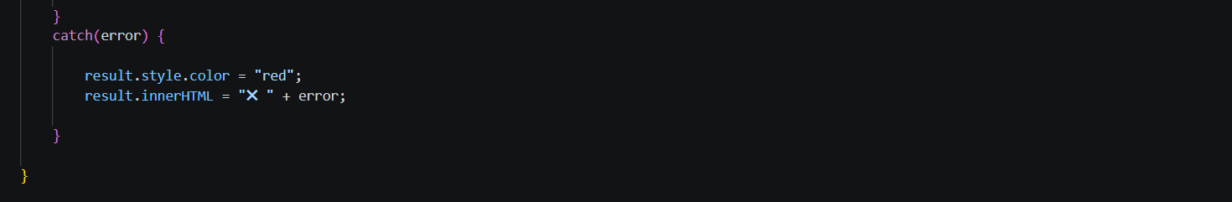

Output Screenshot

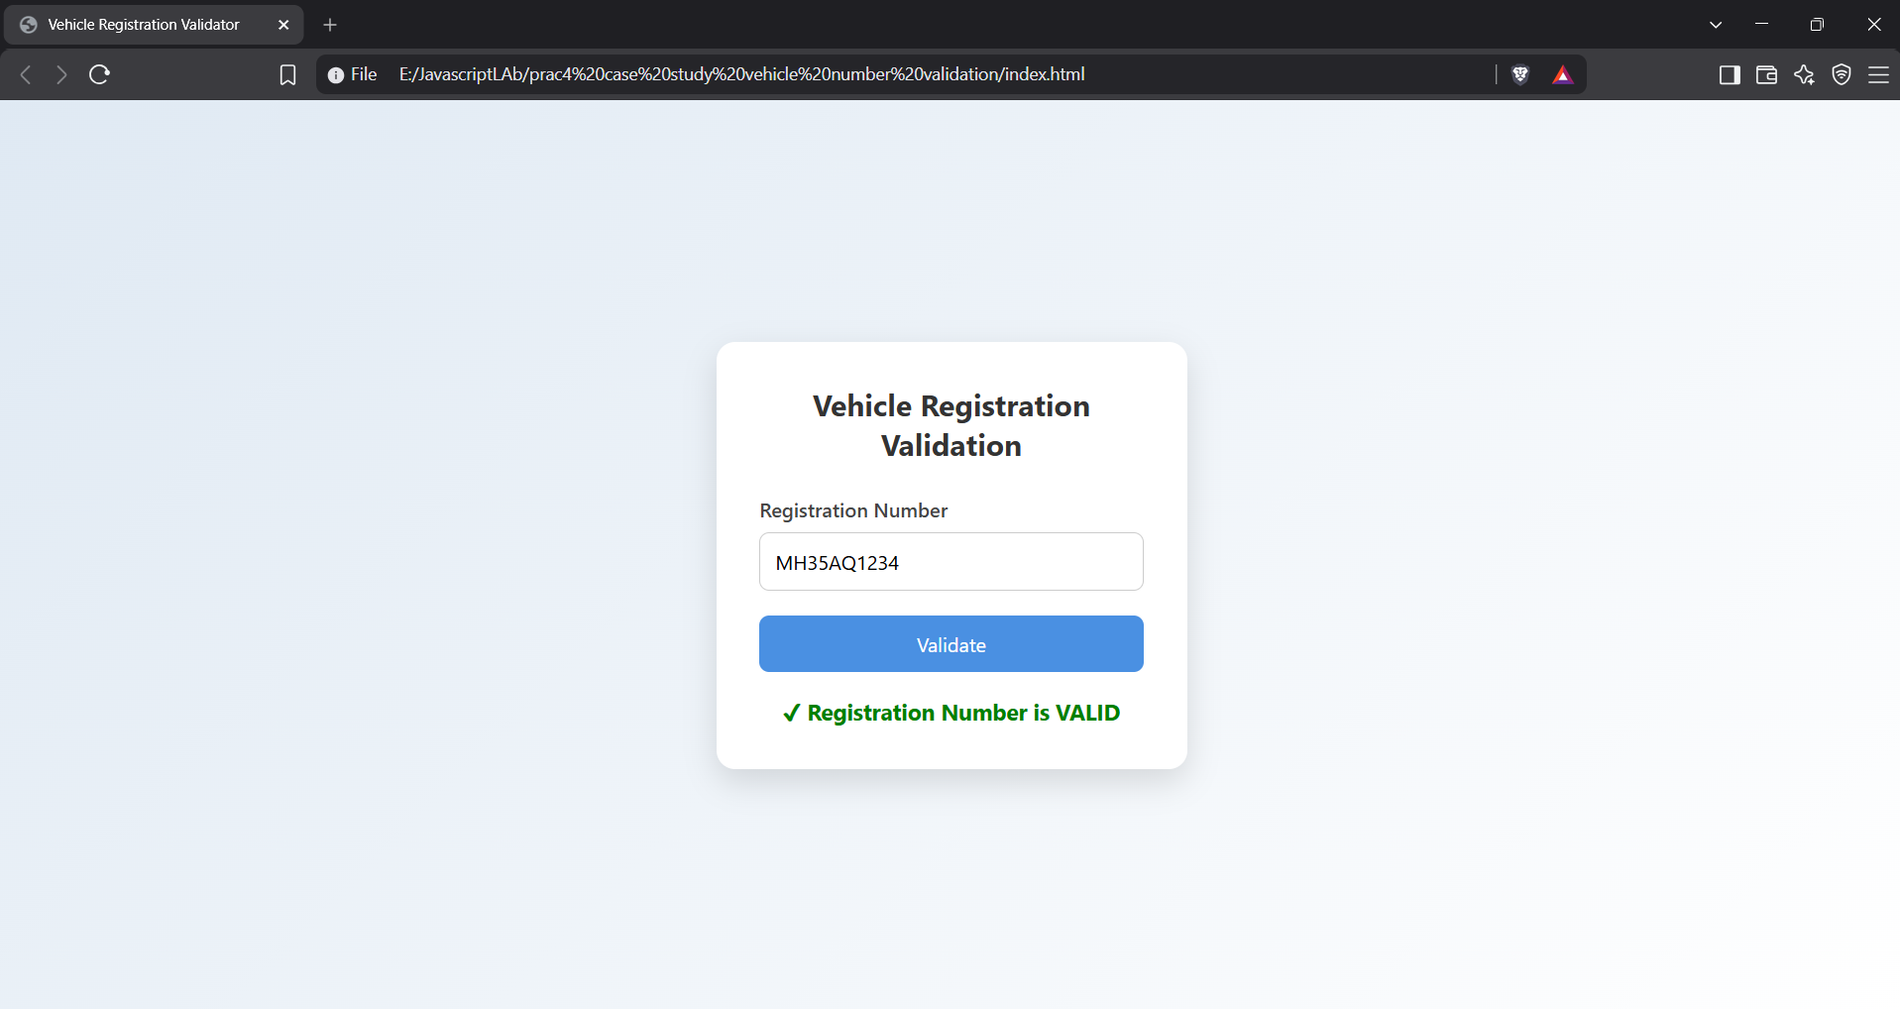

Conclusion
The case study successfully validates vehicle registration numbers by combining regular expressions with JavaScript exception handling. It ensures accurate input validation, provides clear error messages, and improves the reliability and user experience of web-based registration systems.

